

Superseded/repealed from 1 November 2021 – refer to https://www.dit.sa.gov.au/standards/environment

Herbicide Resistance

Environmental Instruction 21.4
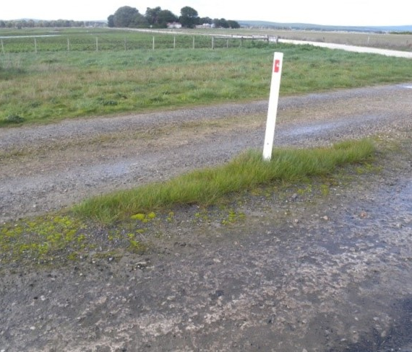

Herbicide Resistance
Environmental Instruction 21.4

First Published: March 2006
Last Updated: March 2018

This document has been prepared by Technical Services, Asset Management in the Department of Planning Transport and Infrastructure. It has been approved and authorised for use by the Department of Planning, Transport and Infrastructure and its authorised agents by:
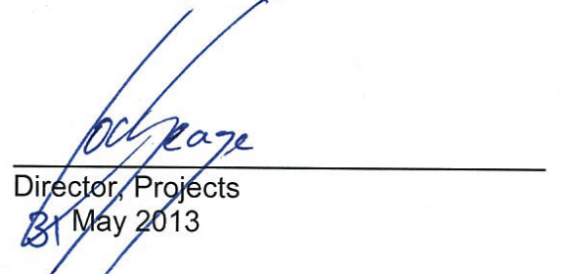

Extracts may be reproduced providing the subject is kept in context and the source is acknowledged. Every effort has been made to supply complete and accurate information. This document is subject to continual revision and may change. To ensure you have the most up-to-date version of this document refer to
Home - Department for Infrastructure and Transport - South Australia (dit.sa.gov.au).

For more information regarding the interpretation of this document, contact:
Technical Services, Principal Environmental Advisor
Telephone: (08) 8343 2595

Contents

1. Scope 4
2. Background 4
2.1 Purpose of herbicide use 4
2.2 Legal responsibilities 4
2.3 Registered herbicides 5
2.4 Schedule 7 poisons 5
3. Herbicide resistance 6
3.1 Causes of herbicide resistance 6
3.2 Evidence of herbicide resistance 6
3.3 Review of DPTI herbicide resistance issues 7
4. Principles of minimising herbicide resistance 8
5. Herbicide maintenance of vegetation 9
5.1 Herbicide maintenance of roadside vegetation 9
5.2 Herbicide maintenance of other vegetation 11
6. References 12
APPENDIX A: Relevant legislation 13
APPENDIX B: Best practice herbicide use 16

Scope
This instruction has been prepared to assist Department of Planning, Transport and Infrastructure (DPTI) staff and contractors to effectively manage herbicide resistance during vegetation control activities. It must be read in conjunction with DPTI’s Master Specification Part L48 Control of Weeds and Herbicide Control of Roadside Vegetation.

This instruction applies to herbicide use by DPTI and its contractors where there is a known or potential issue of herbicide resistance. It has been prepared in response to growing community concern about herbicide resistance and long term sustainability of the herbicide industry. Concerns over herbicide resistance have been raised by independent researchers, farming groups and departmental maintenance staff and contractors.

Background

Purpose of herbicide use
Herbicides are used by DPTI to control vegetation growth, including weeds, for a range of reasons. These reasons include safety (e.g. sight distance, roadside hazards), asset function and protection (e.g. maintenance of shoulders and drains in road and rail corridors), and land management works (e.g. property management, landscape establishment).

Legal responsibilities
The use of herbicides, including licencing, is controlled by legislation (refer to Appendix A for more information).

Under section 25 of the Environment Protection Act 1993, everyone has a ‘general environmental duty’ and a responsibility to take all reasonable and practicable measures to avoid causing environmental harm. When dealing with herbicides there is also a common law duty of care to ensure that no harm is done to yourself, any other person or their property.

The South Australian Environment Protection Authority (EPA) has developed the EPA Guidelines for Responsible Pesticide Use (Updated 2017), which covers herbicide use. Departmental staff and contractors undertaking work for DPTI must consider these EPA Guidelines when planning and undertaking herbicide application as part of weed management activities.

The Natural Resources Management Act 2004 establishes the responsibilities for control of declared plants in South Australia. A list of declared plant species is available on the Weeds in South Australia webpage of the Biosecurity SA, Primary Industries and Regions SA website.

DPTI is responsible for controlling declared plants on properties that it manages, e.g. land owned by the Commissioner of Highways, Minister for Transport or Rail Commissioner which is managed by the department. DPTI is also required to ensure that declared plants are not spread by its activities. The department may, at its discretion, manage declared plants and environmental weeds on road reserves but is generally not legally required to do so.

DPTI has developed a Weeds List (which includes environmental weeds and declared plant species) and a series of regional weed field guides relevant to its work. These documents can be accessed at:
Home - Department for Infrastructure and Transport - South Australia (dit.sa.gov.au).

Registered herbicides
The Australian Pesticides and Veterinary Medicines Authority (APVMA, see website at http://apvma.gov.au) operates the Australia-wide system that evaluates, registers and regulates agricultural and veterinary chemical products. The APVMA maintains the PUBCRIS database (Public Chemical Registration Information System) which contains current details about agricultural and veterinary chemical products registered for use in Australia or which may be available for off-label use under a minor-use permit. To access the database see http://apvma.gov.au/node/10831.

Schedule 7 poisons
Chemicals are either not classified (unscheduled) or classified according to toxicity as being either Schedule 5, Schedule 6 or Schedule 7 chemicals. Signal headings (key warnings) are related to human health and indicate the chemical’s schedule.

Table 1: Toxicity warnings (SA EPA, April 2017, Safe and Effective Herbicide Use: A handbook for near-water applications)
Signal Heading | Schedule | Degree of hazard
No signal heading required; ‘Keep out of the reach of children’ only | Unscheduled | Low toxicity
‘Caution’ | Schedule 5 | Slight degree of hazard
‘Poison’ | Schedule 6 | Moderate degree of hazard
‘Dangerous Poison’ | Schedule 7 | High degree of hazard

Schedule 7 Poisons have a high potential to cause harm at low exposure and require special precautions during manufacture, handling and use. Some examples of the active constituents in Schedule 7 products are aldicarb, dichlorvos, endosulfan, fenamiphos, methomyl, methyl bromide, aluminium phosphide, mevinphos, paraquat.

Based on the health risks associated with Schedule 7 poisons, including the herbicide paraquat (Rural Solutions, 2012), the Department does not endorse the use of Schedule 7 poisons in road maintenance and other weed control activities.

Should a Contractor propose to use a Schedule 7 poison, such as paraquat, they must demonstrate the following to the Department prior to use:
- There is no other viable, less toxic alternative.
- It will not be used in built up areas (i.e. towns, cities) and closer settled areas (e.g. Adelaide Hills, Barossa Valley, the outskirts of Adelaide and major regional centres).
- It will not be used on roadsides immediately adjacent to private dwellings and buildings/facilities that members of the public are likely to frequent (e.g. schools, churches, district halls, sporting clubs etc.)
- It will not be used in/adjacent to roadside parking bays.
- Operators have comprehensive understanding of the risks associated with Schedule 7 poisons, and all legislated and appropriate OHS&W measures are in place.

The Department reserves the right not to accept a proposal for use of a Schedule 7 poison, even if the above conditions are met.

Herbicide resistance

Causes of herbicide resistance
The repeated application of the same herbicide in a single location over a number of years has been documented to result in individual weed species becoming resistant to herbicide applications, i.e. the herbicide becomes ineffective or needs to be applied more often.

Herbicides are grouped according to their mode of action (i.e. the way they work to kill the plant) and the resistance risk. Herbicides which work in a similar way are put in the same group. Repeated use of the same herbicide or herbicide mode of action group will give rise to herbicide resistance. Repeated use of the same herbicide will select for individual plants which are naturally resistant to those herbicide group(s), which will then reproduce and increase in number. It should also be noted that some plants are capable of developing cross resistance to two or more herbicide groups. This is more likely to occur where a single herbicide strategy is used repeatedly over an extended period. Continually changing the mode of action group used will minimise the risk of developing herbicide resistance. Examples of commonly used herbicides and the mode of action group are: Glyphosate Group M, Basta Group N, Amitrole Group Q and Sulfometuron methyl Group B.

Evidence of herbicide resistance
In recent years there has been documented evidence of herbicide resistance of a number of grass species in agricultural areas and along transport corridors around the world, including in Australia and South Australia (Preston 2012). DPTI received an increasing number of reports from internal maintenance staff and contractors of apparent glyphosate resistance in Annual Ryegrass on road verges in a number of areas. Figure 1 shows locations of herbicide resistant Annual Ryegrass (Lolium rigidum) in South Australia based on 2012 surveys undertaken in the Adelaide Hills, Barossa Valley and Mid North.

Figure 2: Herbicide resistance of Annual Ryegrass in South Australia, 2012
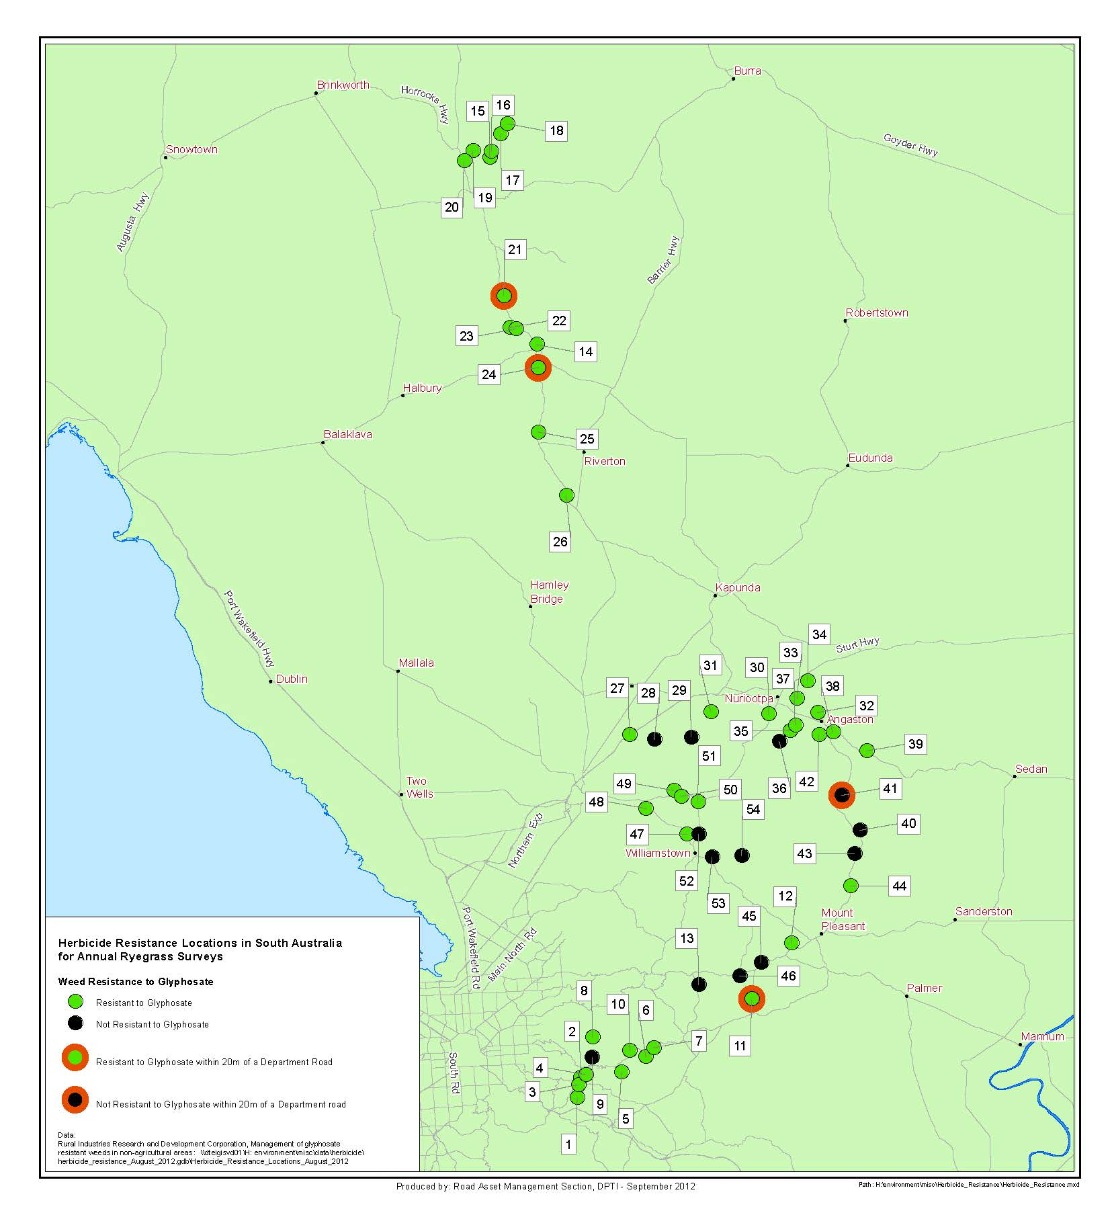

Review of DPTI herbicide resistance issues
In 2012, a report “Managing Risk of Herbicide Resistance in Road Maintenance Practices” was prepared by Rural Solutions for DPTI (knet #6449075).

Historically, repeated applications of glyphosate (generally two to three times per year) were almost the sole herbicide strategy used for maintenance of DPTI road shoulders and around roadside furniture. The main exception to maintenance applications was the use of “special purpose” herbicides for the control of invasive perennial grasses, such as African Lovegrass and Buffel Grass. The high reliance on glyphosate was due to a number of factors including glyphosate’s high effectiveness across a broad spectrum of target plants, its relatively low cost, and its low risk profile in regards to operator and public safety, and the environment.

The Rural Solutions report (2012) outlined alternative weed management methods to minimise the risk of glyphosate or other herbicide resistance. It recommended including manual control methods such as grading and mowing in the control program where possible, and the use of herbicides from different mode of action groups in rotation. A recommended rotation program for road shoulders and asset maintenance, based on mode of action groups, is provided in Table 2. The herbicide options selected for road maintenance activities should be based on the herbicide effectiveness, and minimising risk to human health and the environment.

Principles of minimising herbicide resistance
Departmental staff and contractors undertaking work for DPTI must consider the following principles for minimising herbicide resistance, which have been adapted from a list developed by the Glyphosate Sustainability Working Group:

- strategically use alternative knockdown herbicide mode of action groups (i.e. rotation program)
- use alternate herbicide modes of action including residual herbicides
- consider an integrated approach to vegetation management that includes, where possible, a range/combination of control methods (e.g. mechanical, chemical, biological, grading and mowing)
- use non-herbicide practices aimed at weed seed set prevention, such as mowing, mulching, tillage, burning or grazing
- use a double knock, e.g. full glyphosate rate followed by tillage
- prevent weed control escapes from setting seed
- maintain low weed numbers
- ensure effective property and equipment hygiene to prevent introduction or movement of resistant weed seed
- plant or manage other species to compete with weeds
- monitor the target vegetation to determine the most appropriate intervention level (i.e. use herbicide only when needed, rather than regular calendar application irrespective of need, and apply when the control method will be most effective).

Refer to Appendix B for example Best Practice Work Procedures for general herbicide use.

Herbicide maintenance of vegetation
Master Specification Part L48 Control of Weeds and Herbicide Control of Roadside Vegetation details the requirements for herbicide use by the department and its contractors.

Herbicide maintenance of roadside vegetation
Table 2 provides an example rotation program for herbicide use on DPTI roadsides. DPTI contractors undertaking herbicide control should include the following considerations in their nominated control programs:
- Herbicide rotations based on mode of action groups.
  - Crop Life Australia (2017) provides a non-exhaustive list of herbicides in each Mode of Action Group (https://www.croplife.org.au/wp-content/uploads/2016/08/2017-Herbicide-MOA-Table.pdf).
- Alternative control options in the case of resistant weeds, with nominated lengths of time for herbicide use (e.g. residual herbicides will only be used once a year; herbicides from mode of action group C will only be used every two years).
- Rainfall (e.g. areas with high >600mm average annual rainfall, vs. low to medium areas <600mm average annual rainfall) and soil types.
  - Refer to Figure 2 for a map of DPTI roads overlaid with rainfall data and soil types.
- Proximity to waterbodies (including River Murray Floodplain).
  - Chemicals including surfactants and other additives should be appropriately selected for use in the vicinity of waterbodies.
  - Carfentrazone-ethyl (Hammer) should not be used near waterbodies.
- Use in residential/settled areas.
- Use in areas with susceptible agriculture adjacent.
- Use in areas with sensitive native vegetation adjacent (e.g. Rail or Roadside Significant Sites)
  - DPTI contractors are to refer to the DPTI website for the location and details of Roadside significant sites, and any herbicide use restrictions at specific sites https://www.dpti.sa.gov.au/standards/rssd.

Table 2: Example program for herbicide control of annual vegetation on roadsides
CONTROL SITUATION | Year 1 | Year 2 | Option 1 | Option 2
CONTROL SITUATION | Herbicide use to be rotated annually |  | Alternative available for use where resistant populations or “hard to kill” weeds do not respond to the annual rotations specified
1. medium to low rainfall areas, medium to heavy soil types, low likelihood of water table/catchment issues, non-susceptible broad acre agriculture adjacent, native vegetation present (Typical of Lower, Mid and Upper North, parts of Upper South East, Central Eyre Peninsula, parts of Yorke Peninsula) | Rotation of MOAG* ‘M’ – MOAG ‘Q’ | Rotation of MOAG ‘N’ – MOAG ‘M’ | Rotation of MOAG ‘C’ – MOAG ‘M’ | Mix/rotation of MOAG ‘B’ – MOAG ‘M’
2. medium to low rainfall areas, medium to heavy soils, water table/catchment issues, some susceptible agriculture present, native vegetation present (Typical of Adelaide Plains, parts of Upper South East, parts of Yorke Peninsula, parts of Flinders Ranges, roads adjacent watercourses in Far North) | Rotation of MOAG ‘M’ – MOAG ‘Q’ | Rotation of MOAG ‘N’ – MOAG ‘M’ | Mix/rotation of MOAG ‘B’ – MOAG ‘M’
3. medium to low rainfall areas, sandy soils, non-susceptible broad acre agriculture adjacent, native vegetation present/ or River Murray floodplain (Typical of Eastern and Western Eyre Peninsula, Murray Mallee, Far North, parts of Flinders Ranges, parts of Upper South East, Adelaide Plains, parts of Yorke Peninsula/ or River Murray Floodplain) | Rotation of MOAG ‘M’ – MOAG ‘Q’ | Rotation of MOAG ‘N’ – MOAG ‘M’
4. high rainfall areas, all soil types, potential water table/catchment issues, some susceptible agriculture adjacent, closer settled areas, native vegetation present (Typical of Adelaide Hills, Fleurieu Peninsula, part of Lower Eyre Peninsula, Mid to Lower South East, Kangaroo Island) | Rotation of MOAG ‘M’ – MOAG ‘Q’ | Rotation of MOAG ‘N’ – MOAG ‘M’ | Mix/rotation of MOAG ‘B’ – MOAG ‘M’
*MOAG stands for Herbicide “Mode of Action Group”
** The above table is provided for example purposes only. DPTI Contractors should nominate their own herbicide control program. **

Figure 3: Rainfall and soil types across the DPTI road network
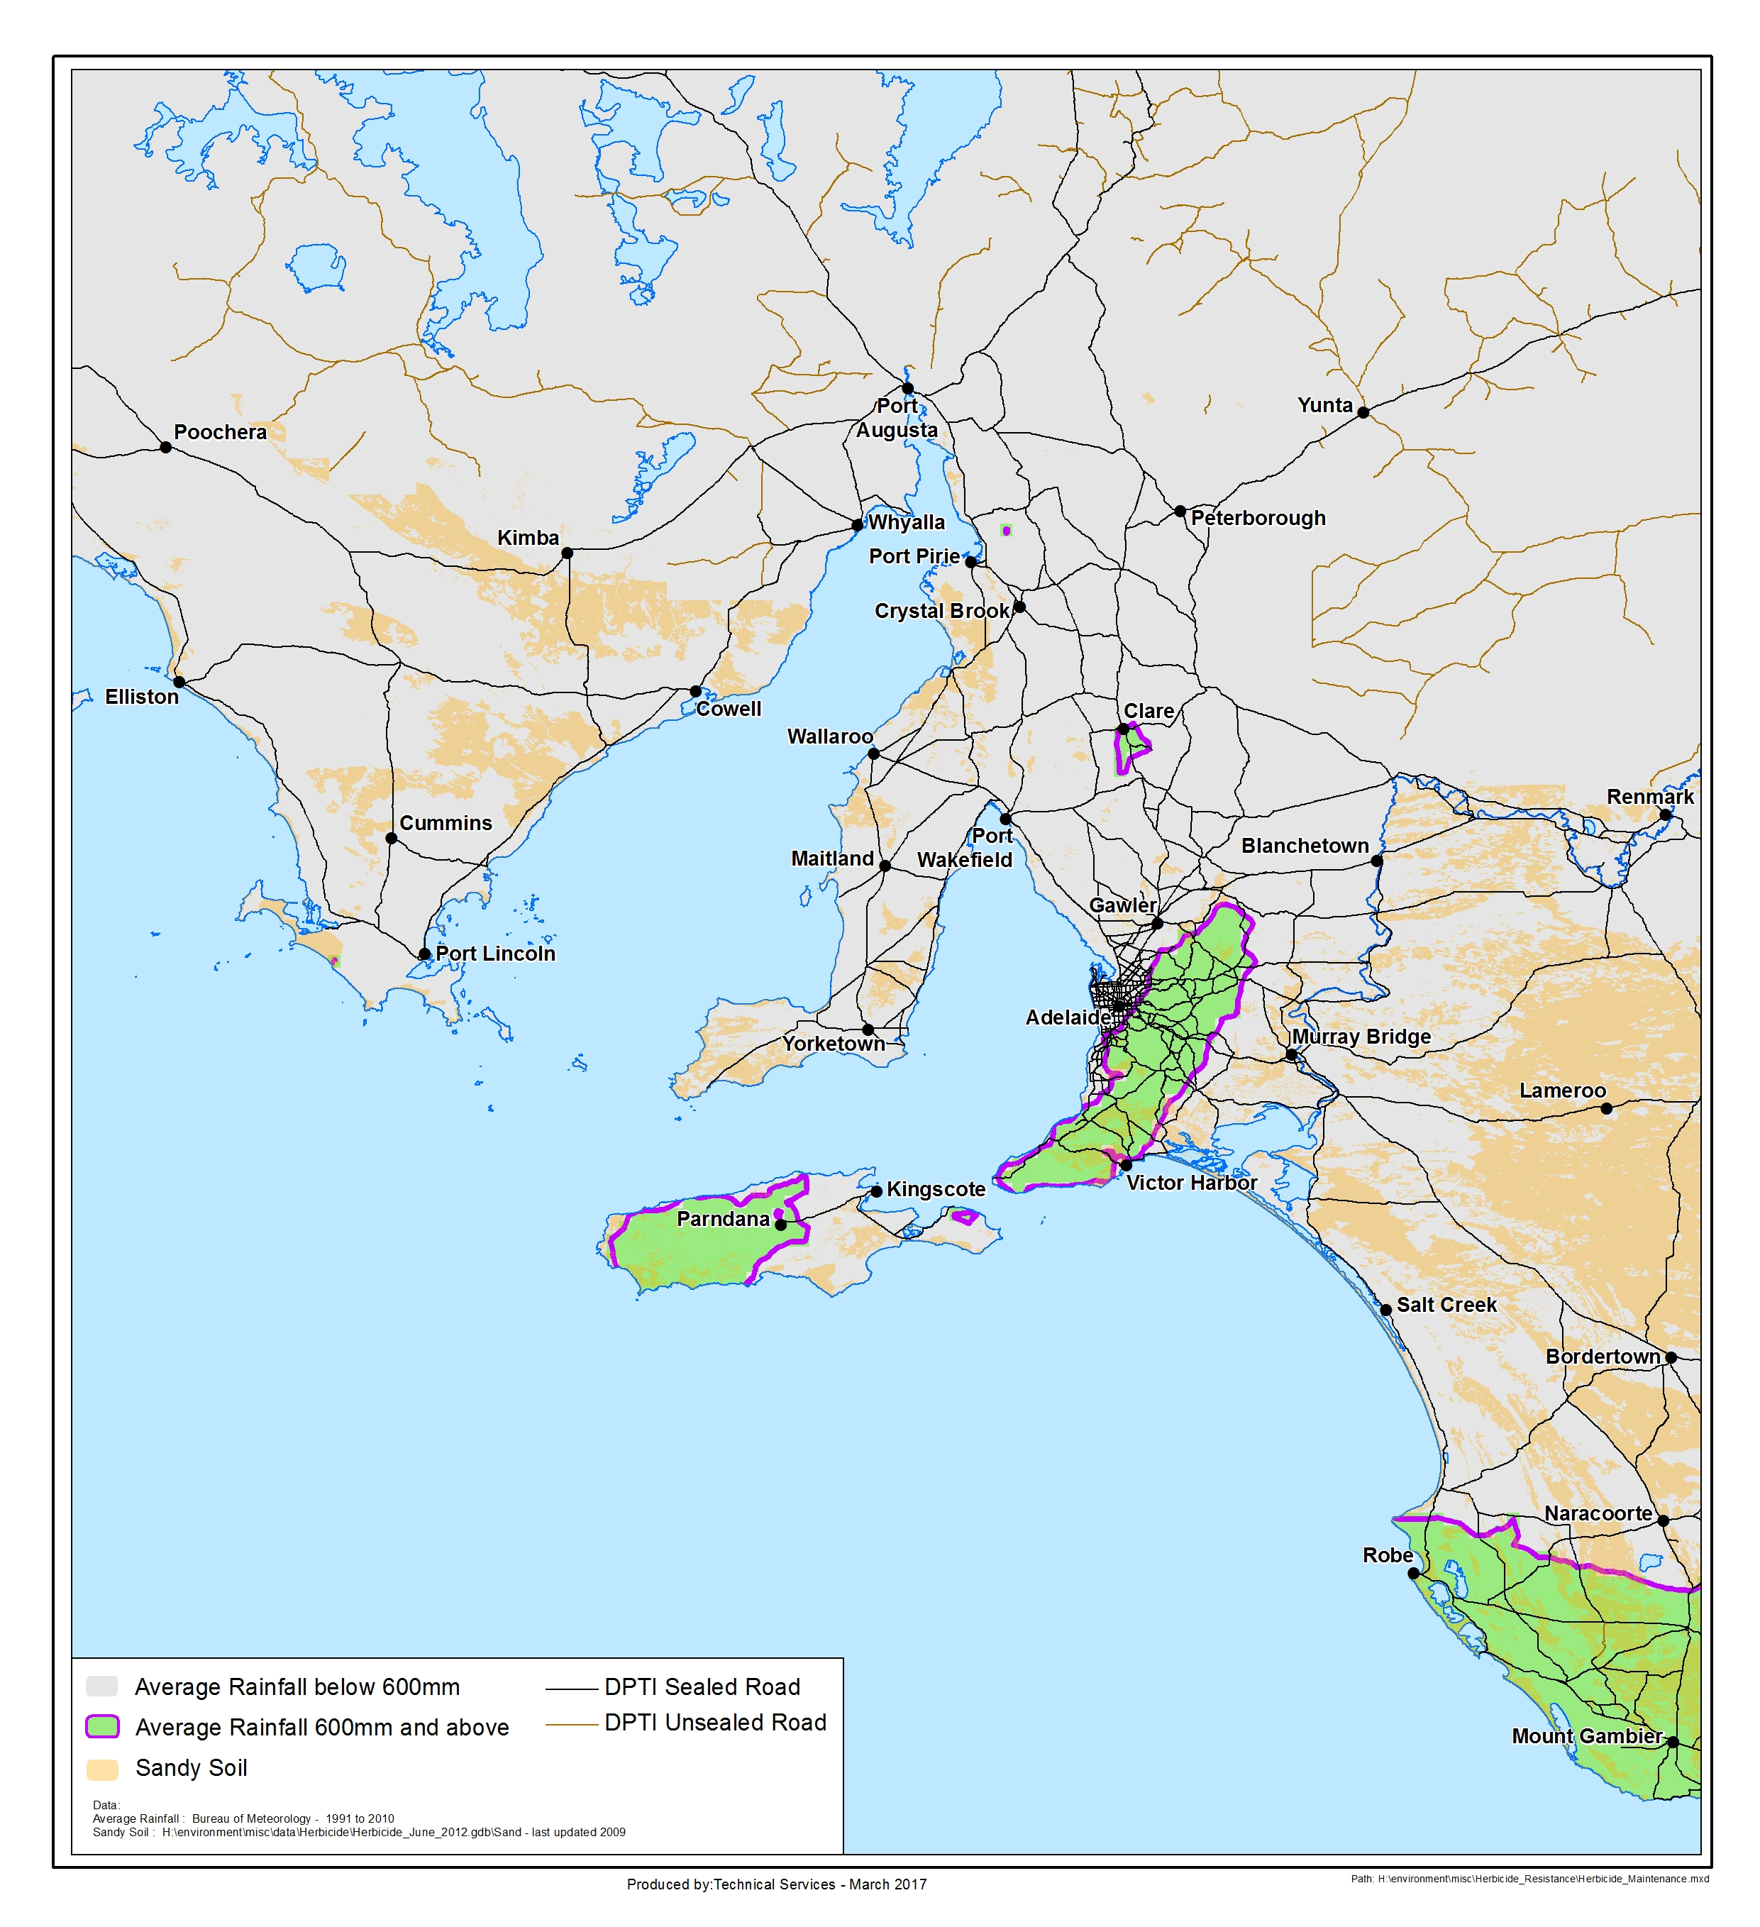

Herbicide maintenance of other vegetation

Herbicides are used for other vegetation maintenance activities, e.g. maintenance of landscape projects, controlling vegetation on rock cuttings, weed control in rail corridors and on land managed by the department, and management of weeds in road verges outside the Maintenance Activity Zone. Herbicide selection and application methods must be specific to the task and plant species. If work involves long term vegetation control, the rotation of herbicides must be considered to avoid herbicide resistance. A wider range of herbicides can be used in rail corridors as public access is limited.

References
Documents
- Australian Glyphosate Sustainability Working Group, Sustainable glyphosate use on roadsides, railways, public utilities and parks (Poster) http://www.glyphosateresistance.org.au/posters/GW%20Poster_roadsides_etc_v6.pdf
- Crop Life Australia (2017), Herbicide Mode of Action Groups, https://www.croplife.org.au/wp-content/uploads/2016/08/2017-Herbicide-MOA-Table.pdf
- Preston, C (2012) Management of glyphosate resistant weeds in non-agricultural areas (PRJ-006914), Australian Government, Rural Industries Research and Development Corporation (knet #6464543)
- Rural Solutions SA (2012) Managing Risk of Herbicide Resistance in Road Maintenance Practices, Report prepared for the Department of Planning, Transport and Infrastructure (knet #6449075)
- SA Environment Protection Authority (Updated 2017), EPA Guidelines for Responsible Pesticide Use, http://www.epa.sa.gov.au/files/477372_guide_pesticides.pdf
- SA Environment Protection Authority (Updated 2017), Safe and Effective Herbicide Use: A handbook for near-water applications www.epa.sa.gov.au/files/477387_pesticide_water.pdf
- University of Adelaide (2013) Managing Risk of Herbicide Resistance in Road Maintenance Practices, Report prepared for the Department of Planning, Transport and Infrastructure (knet #8111816)
Websites
- Australian Glyphosate Sustainability Working Group website http://www.glyphosateresistance.org.au/
- Australian Pesticides and Veterinary Medicines Authority (APVMA) website http://apvma.gov.au
- Biosecurity SA, Primary Industries and Regions SA Weeds in SA webpage http://www.pir.sa.gov.au/biosecurity/weeds_and_pest_animals/weeds_in_sa
- Department of Planning, Transport and Infrastructure (DPTI), Environment Technical Standards and Guidelines (Road & Marine) webpage (including weeds list) Home - Department for Infrastructure and Transport - South Australia (dit.sa.gov.au)
- DPTI Master Specification (Division L Landscape) http://www.dpti.sa.gov.au/contractor_documents/specifications_-_division_L_landscape

APPENDIX A: Relevant legislation
Key legislation related to herbicide use is detailed in this Appendix. This information is not exhaustive. DPTI contractors should not consider the following information to be correct or up-to-date.

Environment Protection Act, 1993

Under Section 25 of the Environment Protection Act, 1993 there is a General Environmental Duty to avoid polluting activities:

A person must not undertake an activity that pollutes, or might pollute, the environment unless the person takes all reasonable and practicable measures to prevent or minimise any resulting environmental harm or nuisance.

When using herbicides there is a duty of care to ensure your actions do not cause harm to the environment, other people or their property, or yourself. This Act controls the pollution of the environment, including pesticide misuse, and the management of wastes, including herbicide wastes. The Act gives the Environment Protection Authority the power to order individuals to stop activities that actually harm, or may potentially harm the environment (Section 93) and place Clean-up Orders (Section 99) on polluters.

Examples of activities that may cause environmental harm due to herbicide use include allowing or causing:
- herbicides to enter stormwater systems, inland waters, groundwaters or marine waters
- herbicides to pollute soils outside your management boundary
- impacts on non-target plants or animals and damaging ecosystem function
- harm to adjacent landowners crops or gardens due to spray drift
- spray drift that causes discomfort, harm, illness or nuisance to neighbouring landowners.

Natural Resources Management Act, 2004

The Natural Resources Management Act, 2004 lists declared plants and provides for their control. Plants are declared under the Act because they pose a risk to primary industries, the natural environment, or public health and safety. The Act:
- regulates entry and movement of declared plants within the State;
- prevents the sale of products contaminated with declared plant seeds of all categories anywhere in the State; and
- refers to the potential of seeds of declared plants to occur as contaminants in produce.

Under the Act the department and its contractors have a legislative responsibility not to spread declared plants through work activities. Landowners and managers are responsible for the control of declared plants on their land. This includes government departments and instrumentalities on land that they own or manage. Natural Resources Management authorities are required to control declared plants on road reserves in accordance with regional priorities (Section 182(7)).

Under section 180(1) of the Natural Resources Management Act, 2004, notification by the owner to the NRM group (or NRM board) of the presence of particular classes of plants or animals is required.

Native Vegetation Act, 1991

The Native Vegetation Act, 1991 is administered by the Native Vegetation Council and controls clearance of native vegetation and provides incentives and assistance to landowners in relation to the preservation and enhancement of native vegetation. The Act requires agencies of the Crown such as the department to obtain consent for clearance of native vegetation. The Act applies to the whole State except inner metropolitan Adelaide.

For the purposes of the Act, "clearance" in relation to native vegetation, means:
- the killing, destruction or removal of native vegetation;
- the severing of branches, limbs, stems or trunks of native vegetation;
- the burning of native vegetation; or
- any other substantial damage to native vegetation, and includes the draining or flooding of land, or any other activity that causes the killing or destruction of native vegetation, the severing of branches, limbs, stems or trunks of native vegetation or any other substantial damage to native vegetation.

For further information on the Department’s legal requirements and procedures for the clearance of native vegetation see the DPTI Vegetation Removal Policy, which is a Standard Operating Procedure under the Native Vegetation Act 1991.

Agricultural and Veterinary Products (Control of Use) Act, 2002

In South Australia the main legislation controlling the use of agricultural and commercial herbicides is the Agricultural and Veterinary Products (Control of Use) Act 2002 (AGVET Act) and the associated Regulations 2004 (AGVET Regulations). This Act is administered and enforced by the Department of Primary Industries and Regions SA.

Section 5 of the Act contains a general duty concerning herbicide use, and this relates to taking all reasonable and practicable measures to prevent or minimise actual or potential contamination, harm to the health or safety of human beings, and other unintended environmental harm. Failure to comply with this duty is not an offence, but compliance may be enforced with a Compliance Order. Failure to comply with an order is an offence.

Under Section 6 of the Act it is an offence to possess an unregistered pesticide unless you have a permit. The easiest way to determine if a product is registered is to search the Australian Pesticides and Veterinary Medicines Authority (APVMA) PUBCRIS database at: http://apvma.gov.au/node/10831.

The Act defines standards for the types of containers and labelling required for the storage of pesticides (Section 8). It also includes mandatory label instructions for the use and disposal of pesticide a legal requirements (Section 7).

Controlled Substances Act, 1984

Under the Controlled Substances Act 1984 any contractors applying herbicides in their business must hold a Pest Controller’s Licence. The Controlled Substances (Pesticides) Regulations 2003 also place conditions on herbicide controllers and technicians (who can obtain a Pest Management Technician’s Licence) in the following areas:
- following label instructions, codes and standards
- transport and storage
- record keeping
- notification of spills.

Further information about licence requirements is available from the SA Government Pest Control Licence webpage, SA Health who administer the licences, and the EPA Guidelines for Responsible Pesticide Use.

Other useful references
The EPA Guidelines for Responsible Pesticide Use contain a summary of pesticide regulation in South Australia.

APPENDIX B: Best practice herbicide use
While herbicide use can have significant benefits, misuse or poor work practices can have harmful consequences for the natural environment and public health.

Departmental staff and contractors must adhere to legislative and contract requirements, including Part L48 Control of Weeds and Herbicide Control of Roadside Vegetation. The EPA Guidelines for Responsible Pesticide Use must also be considered (herbicides are a sub-type of pesticides).

The following best practice work procedures are recommended for all DPTI related herbicide use:

- General contractor requirements

- Have established Work Health and Safety and Environmental Management Systems.
- Ensure all staff are aware of their environmental responsibilities and are provided with appropriate environmental training and induction.
- Ensure that all staff involved in chemical weed control have a relevant Pest Management Technician’s Licence and are operating under a relevant Pest Controller’s Licence (under the Controlled Substances Act 1984 and issued by SA Health).
- Include appropriate environmental requirements in work documentation such as work plans. For example, detail specific requirements for environmentally significant sites (e.g. Roadside Significant Sites, drainage lines and watercourses).

- Control method selection including herbicide selection

- Adopt vegetation control methods that are environmentally and economically sustainable, which will provide more cost effective and longer lasting outcomes.
- Consider an integrated approach to vegetation management that includes where possible a range of control methods (e.g. mechanical, chemical, biological, grading and mowing). Where possible use mechanical as well as chemical control methods.
- Pesticides should be used only when necessary.
- Use only registered pesticides.
- In cases where a choice of chemicals can be economically applied, consider environmental and human health impact during chemical selection.
- Consider the potential of land contamination. This applies to current use of the land as well as potential future use.
- Consider the toxicity of the chemical to human and aquatic life, and the importance of affected water bodies (e.g. drinking water supplies) and select an appropriate control method that minimises these risks.
- Use systemic rather than residual pesticides, where appropriate, to avoid off target kill or surface or ground water contamination.
- Use herbicides that are selective for the specific target species and preferentially have low residual action (i.e. low persistence in the environment), rather than broad-spectrum herbicides. Residual herbicides may be appropriate in circumstances where herbicide resistance is an issue.
- Adopt a herbicide resistance management strategy (refer to Section 4).

- Chemical preparation

- Take care in selecting the location of mixing sites. These sites should be:
  - level to enable accurate measuring and avoid spills
  - located as far as practicable from any water body or entry point into a water body
  - sufficiently isolated from plants and animals, and well ventilated to prevent off-target damage from fumes
  - accessible to clean water for mixing and washing.
- Comply with the instructions on the pesticide label as set out by the AVPMA.
- Wear adequate protective clothing to prevent contact with skin and the inhalation of fumes or dust.
- Care should be exercised with concentrates when preparing mixes.

- Herbicide application guidelines

- Restricted pesticides are to be applied exclusively by persons authorised to do so by the relevant regulatory authority.
- Always consider the circumstances when applying pesticides.
- Applications should be at the minimum dose and frequency possible (as specified on the label), while achieving effective pest management.
- Use an appropriate application technique for the pesticide to be used and the specific task. For example, a cut and swab technique is more selective than spraying for woody weeds, due to the risk of non-target kill from spraying by wind dispersal or vapour drift.
- Maintain application equipment in proper working order and ensure that it is regularly calibrated.
- Identify the target vegetation. The herbicide must not move beyond the targeted application area at all stages of use, including transport. Understand the impact of herbicide use on target and non-target vegetation.
- Ensure correct coverage on the target plant.
- Apply the pesticide when it is expected to be most effective and so that the potential for transport and off target damage is minimised. Consider the ambient moisture, temperature and life cycle stage of the target species.
- Avoid applications under adverse weather conditions such as spraying under windy conditions, granule application before high intensity rainfall events, application on water saturated or freshly tilled soil, volatile chemicals during high temperatures.
- Use a marker dye to enable the public and other stakeholders to identify where pesticides have been applied, to assist the operator in avoiding over or under spray, and to assist in dispute resolution regarding the use of pesticides and their effects.
- Communicate effectively with neighbours and other stakeholders.

- Herbicide use near water

- Do not spray herbicides over water.
- Where possible, undertake herbicide control when the water body or drainage line does not contain water.

- Transport, storage and disposal

- Follow transport, storage and disposal directions provided on the label. Do not remove, conceal, destroy or alter the original label.
- Store pesticides safely, in a cool well-ventilated area well away from water sources.
- Dispose of any surplus pesticides, tank mixes and rinse water according to label instructions. Use the triple rinse method.

- Emergency procedures in the event of a herbicide spill

- Emergency procedures must be developed prior to work commencing and must be implemented in the event of a herbicide spill. Key tasks that must be carried out in the event of a spillage should be identified, including the isolation, containment and clean-up of the spill.

- Records and reporting

- The spray operator must keep and submit records of herbicide applications as specified in Part L48 Control of Weeds and Herbicide Control of Roadside Vegetation.

- Monitor and audit

- Monitor the target vegetation to determine the most appropriate intervention level. Use herbicide only when needed, rather than regular calendar application irrespective of need, and apply when the control method will be most effective
- Undertake and/or participate in environmental auditing as required by the contract.

