1.0 PURPOSE

To provide a procedure for the assessment of the physical properties of crushed quartz for addition to road marking paint as a non-skid additive.

2.0 SCOPE

These instructions pertain to crushed quartz supplied ready for use from manufacturers.

3.0 REFERENCES

- AS 1289.2.1.4: Determination of the moisture content of a soil – Microwave-oven drying method (Subsidiary method).
- AS 2700S (Y35): Colour standards for general purpose – Off White.
- TP134, Particle Size Distribution - Standard method of analysis by sieving

4.0 DEFINITIONS

Nil

5.0 APPARATUS

- As required to AS 1289.2.1.4
- As required to TP134
- Microscope, 10 magnification

6.0 PROCEDURE TO BE FOLLOWED

  - Colour

    - Fill a cylindrical container of minimum diameter 50mm and minimum depth 20mm with a representative sample of crushed quartz and screed off to produce a flat surface.

    - Compare the screeded surface with the Y35 off white colour card of AS 2700S.

    - The quartz shall be whiter than Y35.

  - Moisture Content

    - A representative sample of quartz shall be tested for moisture content, in accordance with AS 1289.2.1.4.

    - Quartz shall have a moisture content of less than 5%.

  - Size Distribution

    - A representative sample of quartz shall be tested for particle size distribution, in accordance with TP134.

    - The size distribution shall be as shown in Table 1.

SIEVE MESH SIZE  (µm) | % PASSING
500 | 100
300 | 50-90
150 | 25-55
75 | 0-30

Table 1 – Size Distribution

  - Shape

    - A representative sample of quartz shall be placed under a microscope with 10 magnification, and the angularity compared with the chart shown as Diagram 1.

    - The quartz shall be very angular, angular or sub angular when assessed according to this procedure.

6.5 Cleanliness

    - A representative sample of approximately 200 quartz particles shall be placed under a microscope with 10 magnification, and the number of foreign particles counted.

    - The maximum number of allowable foreign particles shall be 10.

7.0 DOCUMENTATION

  - Reports
Results shall be reported on the Non-Skid Road-marking Report

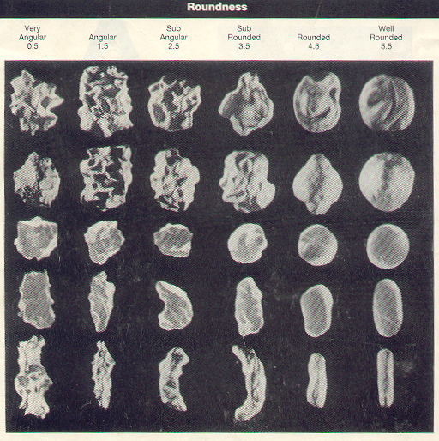

Diagram 1 – Angularity of Particles

