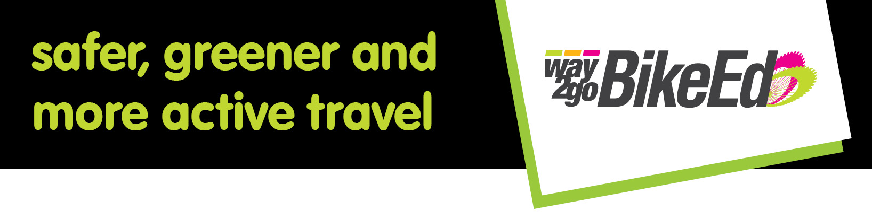Dear Parent/ Caregiver,
Next term our school will be participating in the Department for Infrastructure and Transport’s Way2Go Bike Ed program. It is a practical program for students from year 4-7 delivered by qualified instructors.
Your child will receive a Way2Go Bike Ed student learning journal and a bike check card that will record the roadworthiness check of her/his bike from the first session.
Through participating in Way2Go Bike Ed students:
- build their knowledge and understanding of the road laws and traffic environments
- develop bike handling and maintenance skills
- develop decision making skills for off and on-road bike riding.
Each student will participate in (description here of delivery mode).
Students who own or can access a bicycle are requested to bring it to school for each session. Safe storage will be provided. Bicycle SA has 15 bicycles that are prioritised for students who do not own or cannot access a bicycle.
What you need to know and do
Before the program begins | - Return the permission slip by the due date. It includes essential information about medical conditions and bicycle availability  - If your child is bringing their bike check it for roadworthiness and fit  - Plan with your child how you will transport it to school.  - Make sure that your child has appropriate clothing and closed footwear (avoid skirts and flared pants).
During the program | - Make sure that appropriate clothing and closed footwear is worn  - Carry out any essential repairs identified on the bike check card before the next session.  - Talk together after each session. What did they learn, enjoy, find challenging? What was recorded in their Way2Go Bike Ed student learning journal?  - Practise on the weekend if possible.  - If you have volunteered to assist stay alert to communications. Let teachers and instructors know what you feel comfortable doing and most of all… have fun!
After the program | - Create opportunities to practise by:  - Supporting your child to ride to school - start with a day a week and gradually increase the riding days.  - Joining or forming a school riding group. It’s a great way to share supervision and save time.
If you have any questions ask your child’s classroom teacher. If they are unable to assist they will forward your enquiry to your Way2Go Bike Ed School Co-ordinator.
Return the permission slip to your child’s class teacher by __/__/ 201X.
WAY2GO BICYCLE SAFETY CHECK
This is a great opportunity for your child’s bike to have a free roadworthiness check by either RAA or Bike SA.
Before the first practical session a safety check of the bicycles of participating students will be checked so that:
- safe bicycles are available from the very start and students have more practical riding time
- families receive information about the roadworthiness of their child’s bike. The priority will be to check the safety of student owned bikes. If a fault can be repaired with a minor adjustment or basic maintenance best efforts will be made within the time scheduled. Repairs requiring new parts or major work will be identified on the bike safety check card and referred back to the parent/caregiver for their attention.
- the 15 bicycles available for borrowing are allocated to students who don’t own or have access to a bicycle
What you need to do
Make arrangements to bring your child’s bike to school at X.XXam on the XX Month 201X.
Leave the bike (record a description of where the bikes should be left).
Please note: This is a once only service as RAA staff and Bike SA instructors are scheduled elsewhere and cannot return at a later date.
Students who are using their own bike will receive a completed bike safety check card recording the assessment of its roadworthiness.
Read the assessment information on the card and take any necessary action as recommended below.

Recorded assessment | Action required
Is considered safe and roadworthy | No action required
Requires maintenance or repair | Complete identified repairs before the next session. Completing repairs now can avoid major and more costly repairs in the future.  If you are unable to carry out the identified repairs before the next session immediately advise your child’s teacher so that arrangements can be made for a bicycle to be borrowed.

The Way2Go bike safety check is only available to students participating in the Way2Go Bike Ed program.
If you or family members would like to learn how to do a basic bike check watch the Way2Go bike safety check video at
http://www.dpti.sa.gov.au/Way2Go/bike_ed/way2go_teaching_resource
Thanks for your anticipated cooperation and support.
Kind regards,
Way2Go Bike Ed School Coordinator

Way2Go Bike Ed Parent Permission form
Student full name: ____________________ Class teacher:
Please circle a response to each statement
My child will be nine years old or more when the program begins | YES | NO
My child has a medical condition that may affect his/her safety in the program | YES | NO
My child has a medical condition. The school has an up to date action plan & medication use date is current. | YES | NO
My child can bring an appropriate size Australian standard helmet | YES | NO
My child can bring a roadworthy bicycle of suitable size for his/her height | YES | NO
I can bring the bicycle to the school for a Bike Check before the program starts | YES | NO
I give permission for images of my child to be used by DPTI for media publications | YES | NO
Please place X in the box that best describes your child’s riding ability.
Non rider
Occasional rider
Regular off road rider
Regular on road rider

You may be interested in being a volunteer.
If so consider your options and complete the table below. If not leave the table blank.
I am interested in being a parent volunteer | YES | NO
I have access to my own bicycle | YES | NO
I can attend all sessions | YES | NO
I can attend all sessions at a particular time | YES | NO | am | midday | pm
I can attend only 1 session (identify the exact time) | YES | NO | Day | Date | Time

I understand and accept that my child will ride on local quiet streets under adult supervision and give consent for him/her to participate in the Way2Go Bike Ed program.

Parent/guardian Name (print) ___________________ Signature:_____

