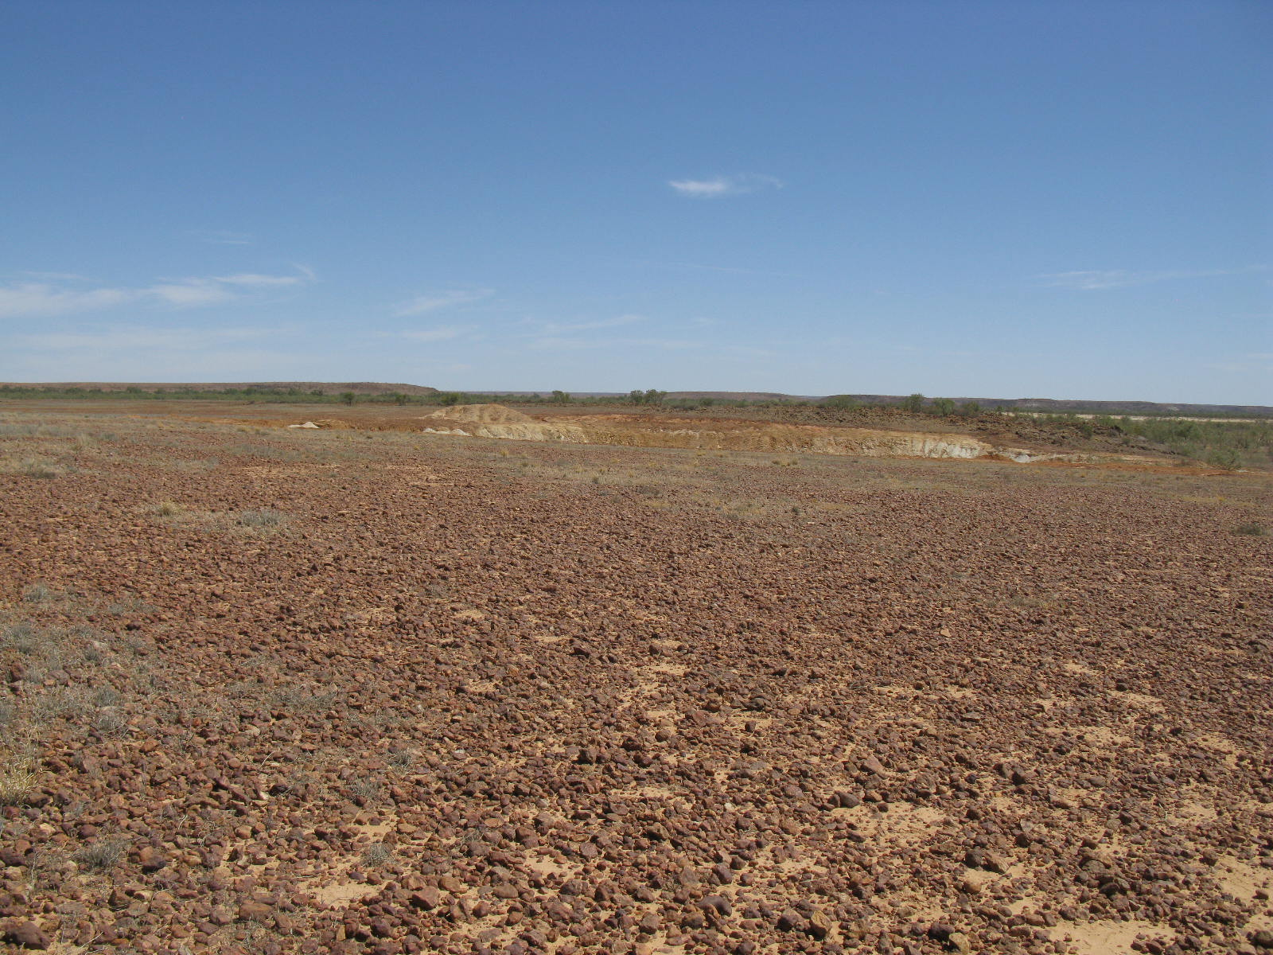

Superseded/repealed from 1 November 2021 – refer to <https://www.dit.sa.gov.au/standards/home>

Contractors’ guide to borrow pits, campsites and other preliminary/ associated works

Department of Planning, Transport and Infrastructure

Borrow Pits associated with DPTI Roadworks: Contractors’ Guide

First published: December 2017

Version 1

Extracts may be reproduced providing the subject is kept in context and the source is acknowledged. Every effort has been made to supply complete and accurate information. This document is subject to continual revision and may change.

To ensure you have the most up-to-date version of this document, refer to

<http://www.dpti.sa.gov.au/documents/home>

For information regarding the interpretation of this document contact:

Technical Services, Asset Management Directorate

Telephone: (08) 8343 2398

Contents

[1. Definitions 3](#_Toc500496377)

[2. Legislative context 4](#_Toc500496378)

[2.1 Borrow Pits within a DPTI road reserve (not APY Land) 4](#_Toc500496379)

[2.2 Borrow Pits outside of a DPTI road reserve (not APY Land) 4](#_Toc500496380)

[2.3 Borrow Pits on APY Land 5](#_Toc500496381)

[3. Procedure to open and operate a borrow pit 7](#_Toc500496382)

[3.1 Preliminary work 7](#_Toc500496383)

[3.2 Gaining Legal Access to Land 7](#_Toc500496384)

[3.3 Environmental Assessment 8](#_Toc500496385)

[3.4 External Approvals and Licences 9](#_Toc500496386)

[3.5 Post approval actions 9](#_Toc500496387)

[3.6 Completion of operations 10](#_Toc500496388)

[4. Campsites, bores, dams, turnarounds and other preliminary/ associated activities 10](#_Toc500496389)

[4.1 Gaining Legal Access to land for campsites and otheractivities associated with roadwork 10](#_Toc500496390)

[4.2 Compensation for campsites and other activities associated with roadwork 11](#_Toc500496391)

[4.3 Procedure to be followed 11](#_Toc500496392)

[Appendix 1: Example agreement 13](#_Toc500496393)

[Appendix 2: Criteria for environmental assessment 5](#_Toc500496394)

[Appendix 3: Example development application 6](#_Toc500496395)

[Appendix 4: Template letter to Chief Inspector of Mines 12](#_Toc500496396)

[Appendix 5: Data to be provided in 6 monthly mining return 13](#_Toc500496397)

[Appendix 6: Template Section 27F Notice 14](#_Toc500496398)

# Definitions

|  |  |
| --- | --- |
| Adjacent: | The Development Act and Regulations do not expressly define when land will be considered “adjacent” to the road. DPTI’s position is that the land does not need to abut the road to be considered adjacent, but must at least be near or close to the road. How close is a matter of degree to be decided in the context of geographical and other factors, eg whether the borrow pit would appear, to the outside observer, to be on the same construction site as the road, whether there are any landscape features (eg creeks, dunes, houses) in between the pit and the road |
| Borrow pit: | A deposit of natural gravel, loam or earth that is excavated for use as a road making material. |
| Owner: | Owner, in relation to land, means a person having an estate or interest (legal or equitable) in land. For the purpose of the Highways Act, this includes Native Title claimants. However, in this procedure, the word land owner does not refer to Native Title claimants. The specific rights of Native Title claimants are discussed separately. |
| ORIM: | Outback Roads Interactive Map, available on DPTI intranet: http://itims.dpti.sa.gov.au/asset/OutbackRoads/ |
| Road Reserve: | Road Reserve is not defined in the Highways Act, however it is accepted to be the area of land that is vested in the Local Council (or the Commissioner of Highways where there is no Council) – typically the land between the edge of travelled way and the fence (or cadastral boundary).  Roads on Crown Land/ Pastoral lease land may not be fenced and there may not be a road ‘reserve‘ delineated on the cadastral map. In such cases it may be possible to search historical gazette notices or management plans for individual leases to determine if a corridor width was ever specified for a particular road. However, the default position is to assume there is no formal road reserve, and an agreement should be sought with the landowner and lessee (if applicable) to open/use borrow pits on the land.  Note that in the APY lands, the road reserve is defined by section 30 of the APY Land Rights Act, as follows:   1. The area comprised within one hundred metres to each side of the centre line of the roads referred to in Schedule 2 (the centre line being ascertained by reference to the road as constructed) constitutes a road reserve. 2. The Commissioner of Highways is entitled to unrestricted use of a road reserve for purposes related to road works. 3. A member of the public shall be entitled to free and unrestricted access to any of the roads referred to in Schedule 2 and to land comprised in a road reserve.   Schedule 2  The Stuart Highway.  The Oodnadatta to Granite Downs Road. |

# Legislative context

The following information applies to the Commissioner of Highways’ (CoH) use of borrow pits for the purpose of extracting road making material for use on DPTI roads. Requirements vary according to pit location and land tenure.

## Borrow Pits within a DPTI road reserve (not APY Land)

**Authority to establish a borrow pit:** s26 of Highways Act gives the CoH power to carry out roadworks, which includes excavation of borrow pit material within a DPTI road reserve.

**Authority to access land:** CoH can freely access land which is under his care and control

**Compensation requirements:** n/a.

**Requirement to pay royalties:** None. The Mining Act does not regulate mining operations or require payment of royalties where the operations are authorised under the Highways Act.

**Requirement to provide information on volume of material extracted:** DPTI provides the Department of State Development with data for all borrow pit material raised by the CoH, regardless of whether royalties are paid.

**Development approval requirements:** Development approval is not required.

**EPA licence requirements:** To comply with s36 and Schedule 1 Part 7 of the Environmental Protection Act, DPTI has a multi-site extractive industry licence (#50206). Unless otherwise specified in the contract, contractors engaged by the Department may operate under this licence.

## Borrow Pits outside of a DPTI road reserve (not APY Land)

**Authority to establish a borrow pit:** CoH can establish borrow pits under s20(1)(ab) or s20C of Highways Act. If a negotiated agreement is not practicable, S20C may be used. S20C gives the CoH[[1]](#footnote-1), with Ministerial approval[[2]](#footnote-2), enabling powers available to local councils under s294 of the Local Government Act 1999 to enter and occupy land for the purpose of opening/ operating a borrow pit.

**Authority to access land:** If establishing a borrow pit on Crown land (including unalienated Crown land, dedicated land and Crown leasehold land (but not Pastoral lease land), authorisation must be sought under section 56A(2) of the Crown Lands Management Act 2009. For Crown leasehold land or dedicated Crown land, consent should also be negotiated with the leaseholder/ custodian in addition to authorisation under section 56A(2).

Section 22(1)(c)(ii) of the Pastoral Land Management and Conservation Act gives the CoH authority to access Pastoral land to establish public roads across the land (which includes associated work). Whilst permission from the pastoral lessee is not legally required, a letter containing relevant information regarding the pit location, proposed access arrangements, timeframes etc should be sent to the lessee.

Permission from the landholder is required to access Freehold land. This is dealt with in the agreement with the landholder established under s20(1)(ab) or s20C of the Highways Act.

**Compensation requirements:** Where a borrow pit is established under S20(1)(ab) of the Highways Act, DPTI may offer compensation to the land owner where it is likely that a land owner will be inconvenienced by the operation of a borrow pit. The amount of compensation should be calculated having regard to the provisions of Section 294(3) of the Local Government Act.

Where a borrow pit is established under S20C of the Highways Act, compensation must be paid to the land owner in accordance with Section 294 (3) of the Local Government Act.

If Native Title is found to exist, Native Title claimants are also entitled to compensation for for any loss, diminution, impairment or other effect the borrow pit has on their native title rights and interests. Compensation must be equivalent to the compensation that would be payable under any other law for the act, on the assumption that the native title holders instead held ordinary title to the land.

**Requirement to pay royalties:** If the borrow pit is opened/operated pursuant to Section 20(1)(ab) of the Highways Act (ie if the CoH enters into a consensual agreement with the land owner), the CoH is exempted from the requirement to pay royalties under Section 7(2) of theMining Act.

If a borrow pit is opened/operated pursuant to Section 20C of the Highways Act (i.e. if the CoH exercises coercive powers under Section 294 of the Local Government Act), royalties will need to be paid to the Director of Mines (Department of State Development). A single payment will be made by DPTI for each 6 month period, and costs will be recovered from individual projects, based on financial details provided in the 6 monthly mining return.

**Requirement to provide information on volume of material extracted:** DPTI provides the Department of State Development with data for all borrow pit material raised by the CoH, regardless of whether royalties are paid.

**Development approval requirements:** Development approval is required to open or expand a borrow pit, except in the following situations:

* if the borrow pit is to be established on land acquired by the CoH under section 20(1)(a) of the Highways Act (due to operation of s20(5) of the Highways Act), or
* if the *adjacent work* exemption set out in clause 1(1)(r) of Schedule 14 of the Development Regulations applies. In order for this exemption to apply all of the following must be satisfied:

(a) The borrow pit is associated with the construction of a road.

(b) The land on which the borrow pit is to be established is adjacent to the road.

(c) The land on which the borrow pit is to be established is associated with the construction of the road[[3]](#footnote-3).

**EPA licence requirements:** To comply with s36 and Schedule 1 Part 7 of the Environmental Protection Act, DPTI has a multi-site extractive industry licence (#50206). Unless otherwise specified in the contract, contractors engaged by the Department may operate under this licence.

## Borrow Pits on APY Land

**Authority to establish a borrow pit:** The *APY Land Rights Act* requires that consent be obtained from the APY for raising of material in the APY Lands, and that the APY/CoH agree on a proposal, as per Sections 31 and 32 of that Act.

**Authority to access land:** as above

**Compensation requirements:** n/a

**Requirement to pay royalties:** The CoH is not liable for a royalty where borrow pit material is raised and used in the APY Lands.

**Requirement to provide information on volume of material extracted:** DPTI provides the Department of State Development with data for all borrow pit material raised by the CoH, regardless of whether royalties are paid.

**Development approval requirements:** Development approval is required to open or expand a borrow pit, except in the following situations:

* if the borrow pit is to be established on land acquired by the CoH under section 20(1)(a) of the Highways Act (due to operation of s20(5) of the Highways Act), or
* if the *adjacent work* exemption set out in clause 1(1)(r) of Schedule 14 of the Development Regulations applies. In order for this exemption to apply all of the following must be satisfied:

(a) The borrow pit is associated with the construction of a road.

(b) The land on which the borrow pit is to be established is adjacent to the road.

(c) The land on which the borrow pit is to be established is associated with the construction of the road[[4]](#footnote-4).

**EPA licence requirements:** To comply with s36 and Schedule 1 Part 7 of the Environmental Protection Act, DPTI has a multi-site extractive industry licence (#50206). Unless otherwise specified in the contract, contractors engaged by the Department may operate under this licence.

# Procedure to open and operate a borrow pit

Unless specified in the Contract, assume that no valid approvals exist for the borrow pit location(s) and all relevant approvals/ clearances must be sought.

## Preliminary work

* + 1. Compile basic information on the proposed pit, including:
* plan(s) showing the location and dimensions of the proposed borrow pit, including aerial photography and at least 4 GPS coordinates of pit boundaries (note that if extending an existing pit, GPS coordinates of the existing and proposed new boundaries must be provided)
* photos showing pit location, visibility, vegetation and topography
* certificate of title/ lease details and ownership details
* details of proposed operation, eg:
* type and volume of material to be extracted and proposed use,
* method of extraction proposed (ripping, blasting, scraper etc), and whether any processing will occur on site,
* pit depth and area of land affected,
* depth and type of overburden,
* timeframe for operation (include start and finish dates, staging arrangements and long term stockpiling needs),
* haulage routes for materials and maintenance proposed for local roads,
* proposed rehabilitation

## Gaining Legal Access to Land

The most appropriate method for the Commissioner of Highways to gain legal access to land for the purpose of operating borrow pits depends on the land tenure. The various circumstances and methods are described below.

When accessing or using land in which native title rights exist it is also necessary to comply with the Native Title Act 1993. Unless the land is subject to an Indigenous Land Use Agreement (ILUA), this will usually mean providing native title holders with the same *procedural* rights as the freehold owner or pastoral lessee. In such cases, a request must be submitted to the Native Title section of Attorney Generals Department to prepare and issue a notice under section 24KA of the Native Title Act that is equivalent to the notice that would be provided under section 294 of the Local Government Act (ie a minimum of 48 hours written notice of entry and any relevant details including details of the land that will be affected).If the land is subject to an ILUA, a request must be submitted to the Native Title section of Attorney Generals Department to prepare and issue a notification in accordance with the provisions of the ILUA. *DPTI must submit requests to the Attorney Generals Department.*

Freehold land

* + 1. In the first instance negotiate verbally with the land owner/ lessee with regard to access to the land and compensation, if applicable (having regard to the information in Section 2 of this document).
    2. If negotiations are straightforward and no compensation is required, prepare a simple written agreement between the CoH and the land owner (template provided in Appendix 1).
    3. If it is considered necessary to offer compensation to the land owner, and/or negotiations are complex, prepare a more detailed agreement between the CoH and the land owner, outlining the particulars of the borrow pit operation and any agreed compensation.
    4. Arrange for two copies of the agreement to be signed by the land owner and the CoH or his delegate (Chief Operating Officer, Safety and Service Division or General Manager, Asset Management at the time of publishing this document). One copy shall be retained by the land owner and one copy shall be retained by DPTI.
    5. If a negotiated agreement with the land owner cannot be reached or is not practicable, prepare and issue a notice in writing pursuant to Section 294 (1a) of the *Local Government Act 1999*. This must be signed and retained as per 3.2.4.

Crown Land(including unalienated Crown land, dedicated land and Crown leasehold land, but not Pastoral lease land)

* + 1. Seek authorisation to operate a borrow pit from Crown Lands via email ([DEWNR.CrownLandsEnquiries@sa.gov.au](mailto:DEWNR.CrownLandsEnquiries@sa.gov.au)) or phone (8204 1218). The email should include a description of the land, a map showing the location of the pit, as well as a copy of all other necessary approval (eg Native Vegetation, Native Title, Aboriginal Heritage, Development approval, landholder consent, as relevant).
    2. For Crown leasehold land or dedicated Crown land, negotiate consent with the leaseholder/ custodian in addition to the above authorisation.

Pastoral Lease Land

* + 1. While pastoral lessees are not *entitled* to be notified of roadworks on pastoral land, it is considered appropriate to provide them with notice as a matter of courtesy. Send a letter to the Pastoral lessee containing relevant information regarding the pit location, proposed access arrangements, timeframes etc.

APY Land

* + 1. Ensure that there is a written agreement between the CoH and the APY in accordance with s 31 and s 32 of the APY Land Rights Act. *DPTI must negotiate this agreement*

## Environmental Assessment

* + 1. Undertake an Environmental Impact Assessment of the proposed pit and associated infrastructure (eg haul roads) in accordance with [Environmental Instruction 21.1: Environmental Approval Procedures](https://dpti.sa.gov.au/standards/home). Key risks to be assessed include Aboriginal Heritage, Native Title and Native Vegetation. In addition, assess proposed pit sites against the criteria in Appendix 2.

* + 1. Specify management measures to minimise environmental impacts during and after the operation of the pit, e.g. by ensuring the base of the pit is not conducive to holding water (can be ripped/fractured or left with rocky material instead of high PI[[5]](#footnote-5) material), implementing erosion control on haul roads (no windrows, minimal gradient, suitable drainage to prevent runoff from concentrating and creating channels).

## External Approvals and Licences

* + 1. Unless the borrow pit falls within one of the exemptions described in Section 2, submit a development application to the **State Commission Assessment Panel** (SCAP) for all new or re-opened borrow pits for which there is no valid approval. Crown Development Application forms are available from the DPTI website. This form should be submitted along with sufficient details to enable an assessment of the impacts of the proposed borrow pit(s). An example application is provided in Appendix 3.

If the borrow pit is in the area of a Council, SCAP will consult the Council as part of the development assessment process. The statutory timeframe for Council consultation is 8 weeks.

Note that Development approval may take up to 3 months from submission of the application.

* + 1. In accordance with regulation 7 of the Mines and Works Inspection Regulations 2013*,* advise the Chief Inspector of Mines of the proposal to open/ re-open a borrow pit. A template letter is provided in Appendix 4. Note that this must be done at least 21 days before commencing operation of the borrow pit. The letter may be posted or emailed to the Chief Inspector (Greg Marshall at the time of publishing this document).
    2. Obtain environmental and heritage approvals and/or undertake notification as required (dependent on the outcome of the Environmental Impact Assessment, Section 3.3). This may include (but is not limited to) approval/ notification under the Native Vegetation Act, Aboriginal Heritage Act and Native Title Act.
    3. If a project expects to raise >100,000 tonnes of material, seek confirmation from the DPTI Senior Pavement Materials Engineer (Technical Services Section) that DPTI’s EPA Extractive Industries licence is current. If the licence is not current (and the contractor does not have own licence) the Project Manager shall provide the Senior Pavement Materials Engineer with a budget line, project and task number, and the Senior Pavement Materials Engineer shall obtain a licence from the EPA licensing team on behalf of the project.
    4. If the borrow pit is to be established on Pastoral Lease land and results in the creation of a new water source that can be used by the lessee for stock on a semi-permanent basis notify DEWNR’s Pastoral Unit Leader (Chris Turner at the time of publishing). Notification is not required if, after work has finished at the borrow pit, no additional water source is provided to the lessee.

## Post approval actions

* + 1. Confirm the date of commencement of operations with the land owner and if applicable arrange payment of compensation to land owner in accordance with the agreement.
    2. Submit the following information to the DPTI Senior Pavement Materials Engineer (Technical Services section):
* Pit name (if applicable)
* Road Number, Maintenance Marker location, offset from road and which side of road
* GPS coordinates of pit boundaries (at least 4)
* Material type and purpose (and approximate PI and Los Angeles Abrasion, if available)
* Area quarried and Area remaining
* Depth
* Volume stockpiled
* Overburden depth
* Area remaining
* Land owner name
* Knet number of landowner agreement
* Knet number of Development approval
* Knet number(s) of Aboriginal Heritage assessment and report/ clearance
* Knet number(s) of Native Title consultation
* Knet number(s) of Vegetation removal approval
* Any useful and relevant comments to summarise clearance conditions/ assist with interpretation of assessment/ approval documents.

The Senior Pavement Materials Engineer will use this information to update the DPTI Outback Roads Interactive Map (ORIM).

* + 1. For each 6-month period that the borrow pit is operating, complete the form in Appendix 5 and submit it to the DPTI Senior Pavement Materials engineer no later than 15 January (for the period 1 July – 31 December) and 15 July (for the period 1 January – 30 June).

## Completion of operations

* + 1. Verify that the environmental management requirements specified for temporary or permanent closure of the pit are implemented (eg erosion control on haul roads, ripping/fracturing the base of the pit to ensure it is not conducive to holding water).
    2. Photograph the pit upon closure/ rehabilitation and submit photo to the DPTI Senior Pavement Materials Engineer, along with confirmation that the required rehabilitation has been undertaken.

# Campsites, bores, dams, turnarounds and other preliminary/ associated activities

Re-sheeting work often involves establishing temporary camps, bores, dams and maintenance turnarounds. It can also involve preliminary activities such as surveys and soil investigations/ test pits.

## Gaining Legal Access to land for campsites and otheractivities associated with roadwork

The process for the CoH to gain legal access to land for the purpose of establishing campsites or undertaking other preliminary or associated activities differs from the process used for borrow pits, mainly because borrow pits are considered part of ‘roadworks’, whereas campsites, test pits etc are dealt with separately.

Section 27F of the Highways Act permits the Commissioner to enter land for a number of specified purposes that are preliminary or ancillary to the doing of roadworks including “doing any other thing necessary for the exercise of the powers of the Commissioner under this Act”, such as establishing campsites to house work crews. The provision applies to freehold or leasehold land (including pastoral lease land) and gives the Commissioner the power to enter Crown land (whether the land is reserved or unalienated). Before exercising this power the CoH is required to give the owner of the land notice in writing.

## Compensation for campsites and other activities associated with roadwork

Section 27F(4) of the Highways Act provides that if an owner suffers any loss or damage as a result of the exercise of the Commissioners powers they are entitled to compensation which is to be determined in accordance with section 29 of the *Land Acquisition Act 1969*. This entitlement will extend to native title holders, either as “owners” for the purposes of the provision, or because of the operation of section 24KA(5) and section 240 of the *Native Title Act*.

## Procedure to be followed

* + 1. In the first instance negotiate verbally with the land owner/ lessee with regard to access to the land and compensation, if applicable (having regard to the information in Section 2 of this document).
    2. Prepare a section 27F notice (template provided in Appendix 6). If it is likely that a site will be occupied multiple times throughout the year, it will be more efficient to detail all intended uses upfront in the initial notice. This must be signed by the CoH or his delegate (General Manager, Asset Management or Manager, Field Services).
    3. If native title still exists, submit a request to the Native Title section of Attorney Generals Department to prepare and issue a notice under section 27F of the Highways Act. To cover all possible scenarios, the notice should include words to the effect that “to the extent that notice is required under s24KA of the *Native Title Act* this notice is served in that capacity”. There is no requirement to provide an opportunity to comment. There is no statutory timeframe, however, a period of 2 months has been standard practice. If project timeframes don’t allow for this, the group should be contacted to agree on a truncated notice period. *DPTI must submit requests to the Attorney Generals Department.*
    4. Undertake an Environmental Impact Assessment of the proposed infrastructure in accordance with [Environmental Instruction 21.1: Environmental Approval Procedures](https://dpti.sa.gov.au/standards/home). Key risks to be assessed include Aboriginal Heritage, Native Title and Native Vegetation.
    5. Specify management measures to minimise environmental impacts during and after the operation.
    6. Obtain environmental and heritage approvals and/or undertake notification as required (dependent on the outcome of the Environmental Impact Assessment). This may include (but is not limited to) approval/ notification under the Native Vegetation Act, Aboriginal Heritage Act and Native Title Act.

Additional requirements that apply to campsites:

If it is proposed to install a septic tank, approval from SA Health is required. This takes a minimum of 14 days to process.

* Obtain the On Site Wastewater Works Approval application form from the SA Health website ([Disposing of Wastewater on site – Forms](http://www.sahealth.sa.gov.au/wps/wcm/connect/public+content/sa+health+internet/protecting+public+health/water+quality/wastewater))
* Select an appropriate location for the septic tank, having regard to the location of natural waterways, creeks, rivers, dams, wells and bores (septic tanks must not be within 50 metres of a water source that is likely to be used for human consumption or agricultural/ stock purposes.
* Geotechnical services technician to undertake site soil testing and prepare a site and soil assessment report to inform the design of the wastewater treatment system.
* Qualified plumber to prepare a detailed sanitary and drainage layout plan. Two copies of the plan should be included with the On Site Wastewater Works Approval application.
* On completion of the installation of the waste water management system forward the certificate of compliance provided by the plumber to SA Health.

Additional requirements that apply to turkey nest dams:

* Unless agreed otherwise security fencing and gates must be erected around the turkey nest, and a safety ladder must be provided to assist with emergency exit from the water

# Appendix 1: Example agreement



|  |  |
| --- | --- |
| *In reply please quote* | *INSERT* |

*Enquiries to INSERT*

*Telephone: INSERT*

(address)

Dear (name)

***RE: Licence for Access & Use of Land***

Thank you for assisting the Commissioner of Highways with its ongoing maintenance of rural and remote roads in your area.

The aid given by adjacent landowners in terms of allowing for our work gangs to set up semi‑permanent camps, excavate source materials from borrow pits and the utilisation of local water supplies, is greatly appreciated and helps us support the local community.

As we have talked about with you, the Commissioner is keen to gain access to your property for the purpose of INSERT (see full details in Attachment A to this letter).

If you are happy to proceed, please sign the “Acceptance of Agreement” enclosed with this letter. In doing so, you will be entering into a legal agreement with the Commissioner of Highways, comprising of the following documents:

* This Letter of Agreement.
* Acceptance of Agreement.
* Attachment A – Access Agreement – Particulars.
* Attachment B – Access Agreement – Terms and Conditions.

Please review this letter and attachments and sign the “Acceptance of Agreement” where indicated in the presence of a witness.

**Please return this letter and the signed ‘Acceptance of Agreement’ form (together with Attachments A and B) to INSERT.**

A copy of the signed Acceptance of Agreement form and Attachments will be provided for your records.

Should you have any questions please contact INSERT on INSERT or email: INSERT.

Yours Sincerely,

*To be signed by either:*

Chief Operating Officer

*or*

General Manager Asset Management

INSERT

INSERT

2016

**ACCEPTANCE** of **AGREEMENT**

I/We……………………………………………………………………………………………………………, as the owner(s) named in Attachment A (“**Owner**”) (or as a person acting on behalf of the Owner(s) with authority to do so) acknowledge and accept the terms and conditions specified in this letter of agreement and in Attachments A and B.

Signature: …………………………………………………………………………………….

Print Full Name: ……………………………………………………………………………..

Date: ………………………………………………………………………………………….

Signature: …………………………………………………………………………………….

Print Full Name: ……………………………………………………………………………..

Date: ………………………………………………………………………………………….

Signed in the presence of:

Witness Signature: ………………………………………………………………………….

Print Full Name: ……………………………………………………………………………..

Date:………………………………………………………………………………………….

1. **THE OWNER(S) OF THE PROPERTY (PRIVATE INDIVIDUAL)**

|  |  |  |  |
| --- | --- | --- | --- |
| Owner: | | 2nd Owner | |
| Full Name: | (Name) | Full Name | (Name) |
| Address: | (Address) | Address: | (Address) |
| 1. **THE OWNER OF THE PROPERTY (CORPORATION)** | | | |
| Registered Name:  ACN:  ABN:  Address: | | | |

1. **DETAILS OF THE PROPERTY**

Certificate of Title: Volume: XXXX Folio: XXXX

Also known as: (address)

1. **TERM**

Commencement Date: The date You sign the Acceptance of this Letter of Agreement.

Expiry Date: INSERT from the Commencement Date (or such other date that may be agreed in writing between the parties).

1. **REPRESENTATIVES**

|  |  |
| --- | --- |
| **Commissioner**  Name:  Position:  Address:  Telephone:  Mobile:  E-mail: | **Owner**  Name:  Position:  Address:  Telephone:  Mobile:  E-mail: |

1. **PERMITTED PURPOSE**

You acknowledge and agree that We and Our Personnel may have access to, remain on and use the Property for, the following purposes:

**Establishment of a Semi-permanent Camp**

INSERT DETAILS OF THE CAMP (i.e. Location and extent of facilities to be erected and serviced) or if no camp is being established state “NOT USED”

**Excavation of source Materials (Borrow pits)**

INSERT DETAILS OF THE EXCAVATION OF MATERIALS (i.e. location and extent of borrow pit) or if no borrow pit is being established state “NOT USED”

**Use and portage of Water**

INSERT DETAILS OF THE USE AND PORTAGE OF WATER (i.e. location of water source and type and how it is to be accessed) or if no use of water is being proposed state “NOT USED”

**ACCESS TO YOUR PROPERTY**

INSERT

INSERT

INSERT

**ADDITIONAL TERMS AND CONDITIONS**

INSERT or NOT USED.

**DEFINITIONS**

In this Agreement unless a contrary intent is evident:

“Agreement” means this Agreement comprising the letter set out above, Attachment A, this Attachment B and any other document expressly incorporated by reference;

“Commissioner” means the Commissioner of Highways a body corporate under the *Highways Act 1926*;

“Our Personnel” means the Commissioner’s officers, servants, agents and contractors and any other person authorised by the Commissioner;

“Owner” means (jointly and severally) the owner(s) of the Property identified in item 1 or item 2 of Attachment A

“Property” means the parcel of land described in item 3 of Attachment A;

“Permitted Purpose” has the meaning set out in item 6 of Attachment A;

“You” means the Owner; and

“We”, “Us” or “Our” is a reference to the Commissioner (as well as to the Commissioner when acting through the Department of Planning, Transport and Infrastructure).

**TERM**

This Agreement starts on the Commencement Date and will continue until the Expiry Date unless terminated (or extended) by the parties in accordance with this Agreement.

The parties may extend this Agreement for an additional period as may be agreed in writing signed by the parties (or their Representatives).

**REPRESENTATIVES**

Each party nominates the person holding the position set out in item 5 of Attachment A as its Representative for the purposes of this Agreement who may exercise the powers and functions of his or her party under this Agreement.

Either party may substitute its Representative from time to time by written notice to the other party setting out the position and contact details of the substitute.

**ACCESS TO YOUR PROPERTY**

We will notify You in accordance with item 7 of Attachment A before We (or Our Personnel) gain access to your Property.

You agree that We (and Our Personnel) may enter and remain on your Property solely for the Permitted Purpose.

You agree to provide Us (and Our Personnel) with sufficient access to your Property to allow for the conduct of the Permitted Purpose in accordance with item 6 of Attachment A.

We acknowledge and agree that We are responsible for obtaining all approvals necessary for Our use of your Property.

We will minimise the disruption to your Property that may arise from Our conduct of the Permitted Purpose and to the extent practicable agree to keep the area of your Property occupied by Us in a clean and tidy condition.

**RISK**

We acknowledge and agree that You do not warrant that your Property is suitable for the Permitted Purpose and that Our (and Our Personnel’s) access, occupation and use of your Property under this Agreement is solely at Our (and Our Personnel’s) own risk.

We release and indemnify You against any costs, expenses or claims which You may incur in connection with any loss of life, personnel injury or loss or damage to Property arising from Our (or Our Personnel’s) occupation of your Property under this Agreement except to the extent that such loss, injury or damage is caused or contributed to by You (or any of Your invitees, employees, agents or contractors).

We warrant that We are entitled to the benefits of the South Australian Government insurance and risk management arrangements administered by the Insurance Division of the South Australian Government Financing Authority (operating under the name “SAICORP”) in respect of Our use of your Property pursuant to this Agreement.

**CHANGE OF OWNERSHIP**

In the event that You intend to sell (or otherwise transfer ownership of) your Property You agree to:

* inform the prospective new owners of the Property of this Agreement; and
* notify Us of the name and contact details of the new (or prospective) owners of the Property.

**GENERAL PROVISIONS**

Either party may terminate this Agreement by written notice to the other party if the other party is in breach of this Agreement and has failed to rectify that breach within 30 calendar days from receipt of a notice requiring rectification.

This Agreement does not create, give rise to or vest any exclusive right of entry or occupation of the Property nor any estate, interest or right of a proprietary nature, in the Property.

If required to give legal effect to this Agreement, by way of formal consideration We must pay $1 (inclusive of GST) on demand to You (no rent or other payment is payable for the access and use of the Property in accordance with this Agreement).

The special terms and conditions set out in item 8 of Attachment A (if any) form part of this Agreement.

Nothing in this Agreement derogates from the powers of the Auditor-General under the *Public Finance and Audit Act 1987* (SA).

Any modification of this Agreement must be in writing and signed by each party (or by its Representative).

The laws in force in South Australia apply to this Agreement. The courts of South Australia have non‑exclusive jurisdiction to determine any proceeding in relation to this Agreement. Any proceeding brought in a Federal Court must be instituted in (and remain with) the Adelaide Registry of that Federal Court.

# Appendix 2: Criteria for environmental assessment

*Adapted from DMITRE’s 2014 review of Goal Attainment Scaling criteria for borrow pit construction and rehabilitation under the Petroleum and Geothermal Energy Act 2000*

|  |  |  |
| --- | --- | --- |
| **Goals** | **Outcome** | |
| **Desirable** | **Undesirable** |
| Pit sited to minimise erosion | Gibber plain and table land | |
| * Pit located on flat terrain * Gibber mantle around pit intact (rolling only) * No windrows on tracks | * Pit located on sloping terrain (>1% slope) * Gibber mantle around pit removed * Windrows on tracks |
| Dunefields | |
| * Pit located on terrain with <2% slope | * Pit located on terrain with >2% slope |
| Floodplain | |
| * Pit located >100m from any creek channel, waterhole, terrace or levee | * Pit located within 100m from any creek channel, waterhole, terrace or levee |
| Pit sited to minimise water retention | * Floodplain/ claypan areas avoided where possible * Where floodplain/claypan areas are unavoidable, pit located away from low points | * Pits located in low points within floodplain/ claypan areas |
| Perrenial vegetation clearance avoided | * Trees or shrubs removed only where there is no alternative * No trees or shrubs with hollows removed | * Large trees (>30cm diameter) removed * Trees or shrubs with hollows removed |
| Protect sites of natural, scientific or heritage significance | * Sites avoided | * Sites disturbed |
| Visual impact | * Pit not visible from public road or screened by vegetation | * Pit clearly visible – not screened |

# Appendix 3: Example development application



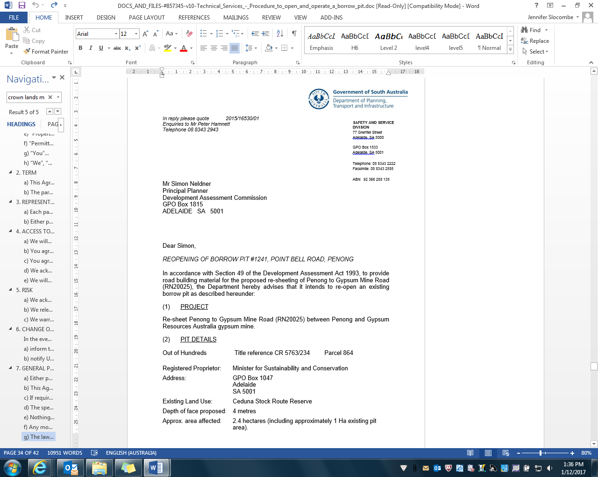

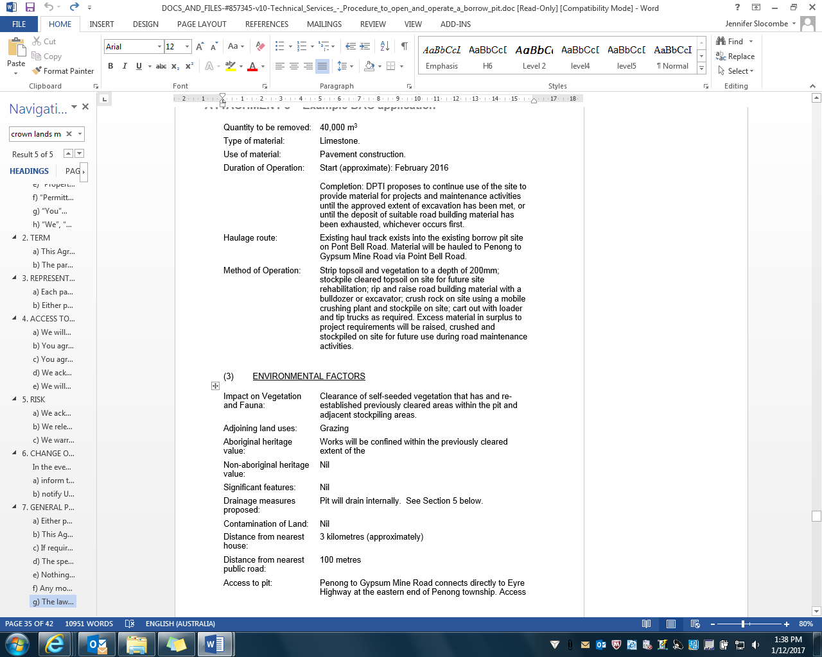



LOCALITY PLAN – Pit ID #1241, Point Bell Road, Penong

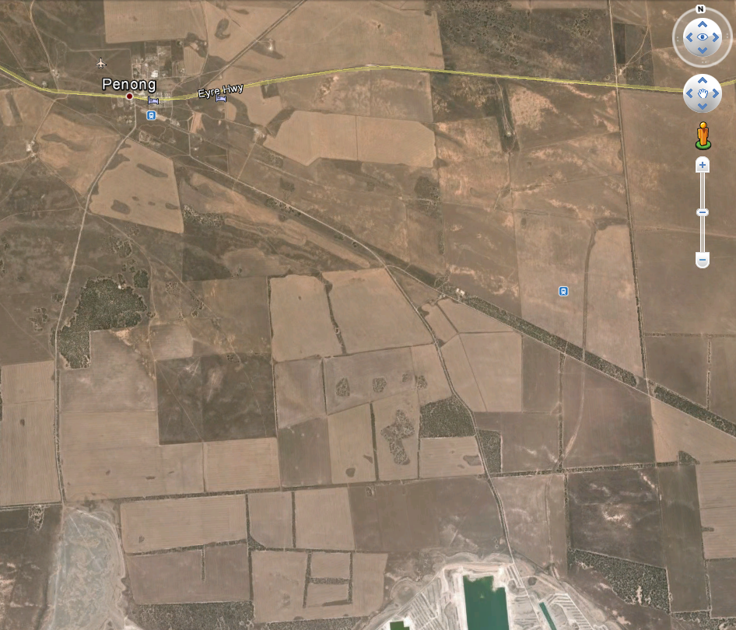

Existing Pit

Penong

Penong to Gypsum Mine Road

GRA Gypsum Mine

SITE PLAN: Extent of pit extension

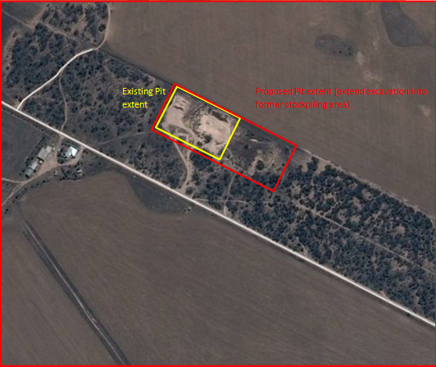

|  |  |  |
| --- | --- | --- |
| Appendix 4: Template letter to Chief Inspector of Mines | | |
|  |  | DPTI_Logo_Flat |

**SAFETY AND SERVICE**

**DIVISION**

77 Grenfell Street

Adelaide SA 5000

GPO Box 1533

Adelaide SA 5001

Telephone: 08 8343 2222

Facsimile: 08 8343 2585

ABN 92 366 288 135

|  |  |
| --- | --- |
| *In reply please quote* | *----/----* |

*Enquiries to* *Project Manager*

*Telephone* *(08) Phone Number*

Greg Marshall

Chief Inspector of Mines

Mineral Resources

Department of State Development

GPO Box 320

ADELAIDE SA 5001

Dear Mr Marshall,

*Proposal to open/ reopen borrow pit*

The department is planning to open/ reopen a borrow pit at [insert CT/CL, Section, Hundred, GPS coordinates]. The borrow pit will be used to supply road building material required for [insert project description].

It is anticipated that [insert approx volume] of material will be raised for this project, and the pit will be worked from [insert approx commence date] to [insert approx end date].

Please acknowledge receipt of this notification, for the purpose of satisfying Regulation 7 of the *Mines and Works Inspection Regulations 2013*.

Yours sincerely,

PM name

Project Manager

23 December 2015

# Appendix 5: Data to be provided in 6 monthly mining return

The following data for each 6-month period to be submitted to the DPTI Senior Pavement Materials Engineer (Technical Services section) no later than 15 January (for the period 1 July – 31 December) and 15 July (for the period 1 January – 30 June):

|  |
| --- |
| Project name: |
| Location of site *(include road running distance or coordinates if available):* |
| Crushing contract number: |
| Tonnage (as accurately as possible) of material raised in the applicable six-month period1: |
| Tonnage of material used in the applicable six month period: |
| Type of commodity, as per Section C of the Mining Returns Form 26: |
| If the borrow pit was established pursuant to Section 20C of the *Highways Act*, record or evidence of quantities raised (e.g. a receipt from the supplier) |
| Approximate cost per tonne to crush2: |
| Tonnage (as accurately as possible) of any material supplied to the land owner (either as part of or in addition to the agreement with the land owner): |
| Project financial details - Budget line, project and task number *(for payment of royalties, if applicable)*: |

*1 This refers only to material raised in that period, not stockpiled material that was raised at other times*

*2 This information is used to estimate the market value of the material, as required by Section C of the Mining Returns Form*

|  |  |  |
| --- | --- | --- |
| Appendix 6: Template Section 27F Notice | | |
|  |  | DPTI_Logo_Flat |

*Enquiries to*

*Telephone*

**SAFETY AND SERVICE DIVISION**

77 Grenfell Street

Adelaide SA 5000

GPO Box 1533

Adelaide SA 5001

Telephone: 08 8343 2222

Facsimile: 08 8343 2768

ABN 92 366 288 135

Name

Address Line 1

Address line 2

SUBURB SA XXXX

Dear Sir/ Madam,

*Access to land for the purpose of ESTABLISHing a campsite*

I am authorised in writing by the Commissioner of Highways to give notice under section 27F of the *Highways Act 1926* regarding entry on land. Section 27F permits the Commissioner to enter land for a number of purposes that are preliminary or ancillary to roadworks.

The Commissioner of Highways requires access to the property described below for the purpose of establishing and using campsites to house work groups:

* Allotment XXX in Files Plan XXXXX comprised in Certificate on Title Register Book Volume XXXX Folio XXX; and
* Allotment XXX in Filed Plan XXXXXX comprised in Certificate of Title Register Book Volume XXXX Folio XXX

The location of the campsites is shown on the attached map.

Access requirements

It is anticipated that work groups will access the above property on (insert dates).

Land will be used for (insert description, eg parking of vehicles, pitching tents/ caravans?? etc). All solid and liquid waste will be removed from site? Any other relevant details?

If you suffer loss or damage as a result of these works, you may be entitled to compensation to be determined in accordance with section 29 of the *Land Acquisition Act 1969*.

If you have any concerns or questions about these works please contact (insert name) on (insert phone number).

Yours sincerely,

*To be signed by either:*

Manager, Field Services

*or*

General Manager Asset Management

Name

Position

Date

1. The Chief operating Officer, Safety and Service Division and the General Manager, Asset Management Directorate are authorised to exercise these powers in relation to contracts not exceeding the financial limits specified in DP001 [↑](#footnote-ref-1)
2. Minsterial approval has been granted for contracts not exceeding $500,000 in value [↑](#footnote-ref-2)
3. The procurement of land, or entering into an agreement to use the land specifically for the purpose of a borrow pit would fulfil this criterion. [↑](#footnote-ref-3)
4. The procurement of land, or entering into an agreement to use the land specifically for the purpose of a borrow pit would fulfil this criterion. [↑](#footnote-ref-4)
5. Plasticity Index [↑](#footnote-ref-5)