Vests and name tags
A bright vest will be supplied for each student that participates in the program. Each vest will have a large number on it. Students must wear the same vest every session to:
- create a habit of wearing the bright vest before the on road riding sessions. This will complement the message from topic 1 in the Way2Go Bike Ed teacher’s resource

- help instructors to observe and communicate with students from a distance (when name tags can’t be seen)

- aid in completing the student assessment checklist.

Students will also be expected to wear a name tag in a visible position. Please make sure this is worn over the top of their vest. This will help the instructors to communicate with students using their name when possible.
If you already have name tags for each student in your class and wish to use them please check that they are:
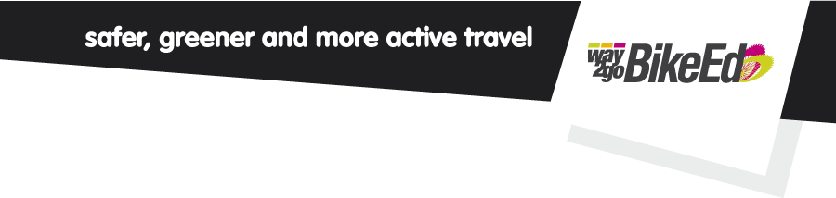
- clearly visible from a distance. Use BIG BOLD TEXT

- waterproof and durable

- easy for students to attach to themselves independently.

If you do not have name tags you can use the template provided on page 2.

Name | Name
Name | Name
Name | Name
Name | Name

